
Berwang Music ’26

Booking Form

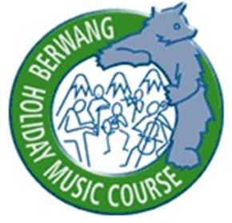
Please complete this form and return to admin@berwangmusic.com at the same time as making payment.

Full Name (in CAPS) including first name
Voice (S1/S2/A1/A2/T1/T2/B1/B2)
Please briefly state choral experience
I wish to be considered for the Vocal Ensemble | Yes / No (delete as applicable)
If available, I would like to have an individual singing lesson | Yes / No (delete as applicable)
If wishing to be selected for the Vocal Ensemble, please state relevant experience on a separate sheet of paper and send to Tim at tcb21@cam.ac.uk

Mobile number (inc. country code)
Email
Country
First language
Sharing personal data: please type your name if you are happy for your phone number to be shared within the course What’sApp group (which will be used for communication during the course)
I agree to abide by the Terms and Conditions (please type name)
Please state how you found out about Berwang Music
Accommodation (if known)

For payment by bank transfer
Account Name: Berwang Music | Account Number: 51775758
Bank: HSBC | IBAN: GB49HBUK40132251775758
Sort Code: 40-13-22 | BIC: HBUKGB4121L

For payment by credit/card with Early Bird Discount for bookings made by 1 November – 31 December 2025
Deposit of £50 to be paid at time of booking OR | https://pay.sumup.com/b2c/QLY467CU
Full Fee at the time of booking with Early Bird Discount £365 | https://pay.sumup.com/b2c/QPGZS0IF
For payment by credit/card for bookings made from 1 January 2026
Deposit of £50 to be paid at time of booking OR | https://pay.sumup.com/b2c/QLY467CU
Full Fee at the time of booking £390 | https://pay.sumup.com/b2c/QE0TENKF

